|  |  |  |  |  |  |  |  |  |  |
| --- | --- | --- | --- | --- | --- | --- | --- | --- | --- |
|  |  | | | | | | | | |
|  |  |  |  |  |  |  |  |  |

Student Number

**ST PIUS X COLLEGE**

**CHATSWOOD**

**HSC 2017 Stage 6 – Year 12**

**ASSESSMENT TASK #2**

**25% of School Based Assessment**

**MATHEMATICS**

**General Instructions**

* Working time – 2 hours
* Reading time – 5 minutes
* Write using black or blue pen

Black pen is preferred

* Draw diagrams using pencil
* NESA approved calculators may be used
* Marks maybe deducted for careless or poorly arranged work
* Show all relevant mathematical reasoning and/or calculations
* Write your Student Number at the top of all pages

**Total Marks – 70**

**Section I – Multiple Choice 10 marks**

* Attempt Questions 1 – 10
* Enter responses on the multiple choice   
   answer sheet
* Allow 10 minutes for this Section  
    
  **Section II – 60 marks**
* Attempt Questions 11 – 14
* Show all necessary working
* ***Start each question in a SEPARATE booklet***
* Allow 1 hour and 50 minutes for this section

**SECTION I – MULTIPLE CHOICE** 1 mark per question **10 Marks**

***Use the multiple choice answer sheet.***

Select the alternative A, B, C or D that best answers the question. Fill in the response oval completely.

|  |  |  |  |
| --- | --- | --- | --- |
| (A) 2 | (B) 6 | (C) 8 | (D) 9 |

Sample: 2 + 4 =

|  |  |  |  |
| --- | --- | --- | --- |
| A | B | C | D |

If you think that you have made a mistake, put a cross through the incorrect answer and fill in the new answer.

|  |  |  |  |
| --- | --- | --- | --- |
|  |  |  |  |

If you change your mind and have crossed out what you consider to be the correct answer, then indicate the correct answer by writing the word **correct** and drawing an arrow as follows.

**correct**

|  |  |  |  |
| --- | --- | --- | --- |
|  |  |  |  |

1. What is the value of $\sqrt{\frac{π+1}{5}}$, correct to 3 significant figures?
2. 0.91 (B) 0.910 (C) 1.83 (D) 0.9101
3. What is the slope of the line with equation $2x-4y+3=0$?
4. $-2$ (B) $-\frac{1}{2}$ (C) $\frac{1}{2}$ (D) 2

1. Which equation represents the line perpendicular to $2x-3y=8$, passing through the   
   point (2, 0)?  
     
   (A) $3x+2y=4$ (B) $3x+2y=6$ (C) $3x-2y=-4$ (D) $3x-2y=6$

1. Which expression is a factorisation of ${27x}^{3}-8?$
2. $\left(3x+2\right)\left({9x}^{2}-6x+4\right)$ (B) $\left(3x-2\right)\left({9x}^{2}+6x+4\right)$

(C) $\left(3x-2\right)\left({9x}^{2}+12x+4\right)$ (D) $\left(3x+2\right)\left({9x}^{2}-12x+4\right)$

**5.**

$${30}^{°}$$

A

B

C

D

16 cm

$${74}^{°}$$

Diagram not to scale

In the diagram, the length of AB correct to 2 decimal places is?

1. 8.00 cm (B) 11.07 cm (C) 11.52 cm (D) 55.80 cm
2. For the angle $θ$, $sinθ=\frac{7}{25}$ and $cos=-\frac{24}{25}$.

Which diagram best shows the angle $θ$?

(A) (B) (C) (D)

   

**7.**



The diagram shows the graph of $y=e^{x}\left(1+x\right).$  
  
How many solutions are there to the equations $e^{x}\left(1+x\right)=1-x^{2}$?   
  
(A) 0 (B) 1 (C) 2 (D) 3

**8.** A bag contains 4 white counters and 6 yellow counters. Three counters are selected at   
 random without replacement.  
  
 What is the probability that at least one of the counters selected is white?   
  
 (A) $\frac{1}{6}$ (B) $\frac{1}{2}$ (C) $\frac{5}{6}$ (D) $\frac{29}{30}$

**9.** In ∆ABC a line segment, PQ, is drawn from   
AB to AC. PQ is parallel to BC.

Q

$$2x$$

$${58}^{°}$$

$${66}^{°}$$

A

B

C

P

Diagram not to scale

What is the value of *x*?

1. 28
2. 33
3. 56
4. 66

**10.** Which curve best represents the **gradient function** of $f\left(x\right)=\log_{e}{(x+1)}$**?**

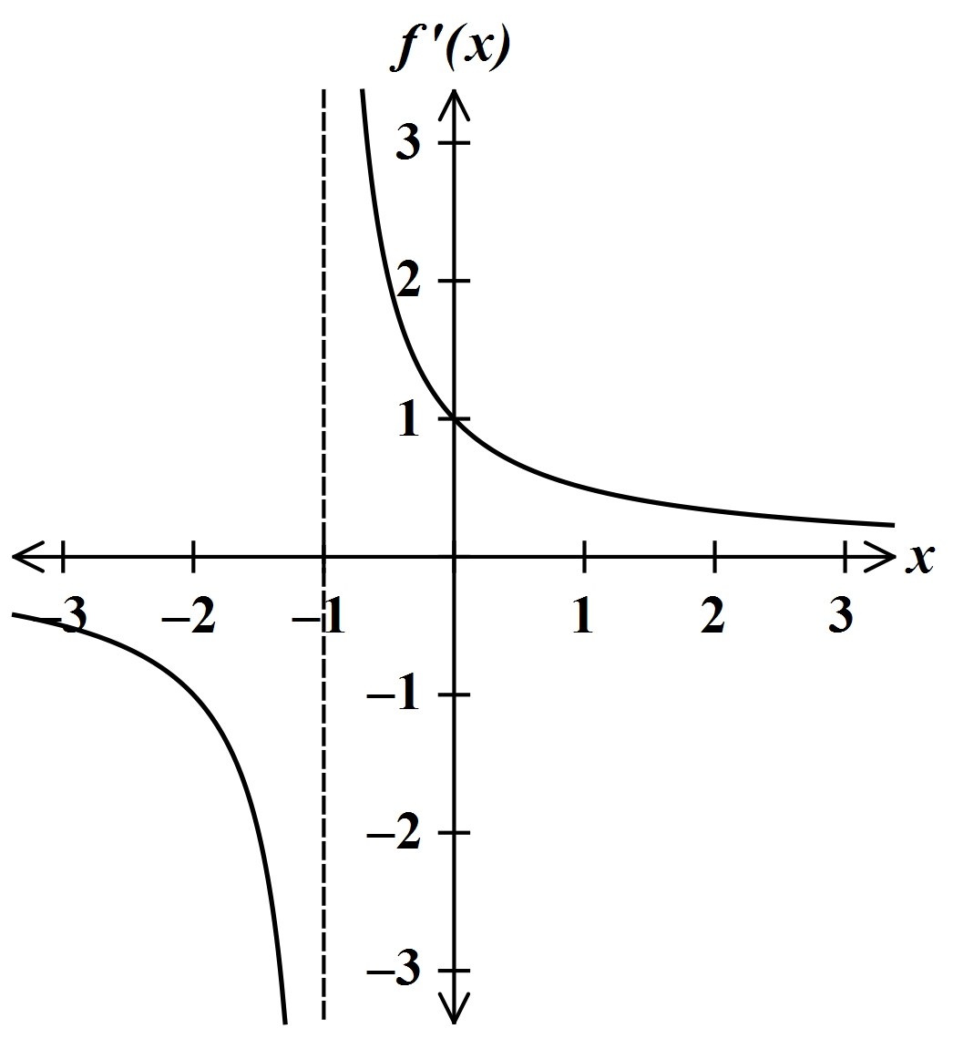

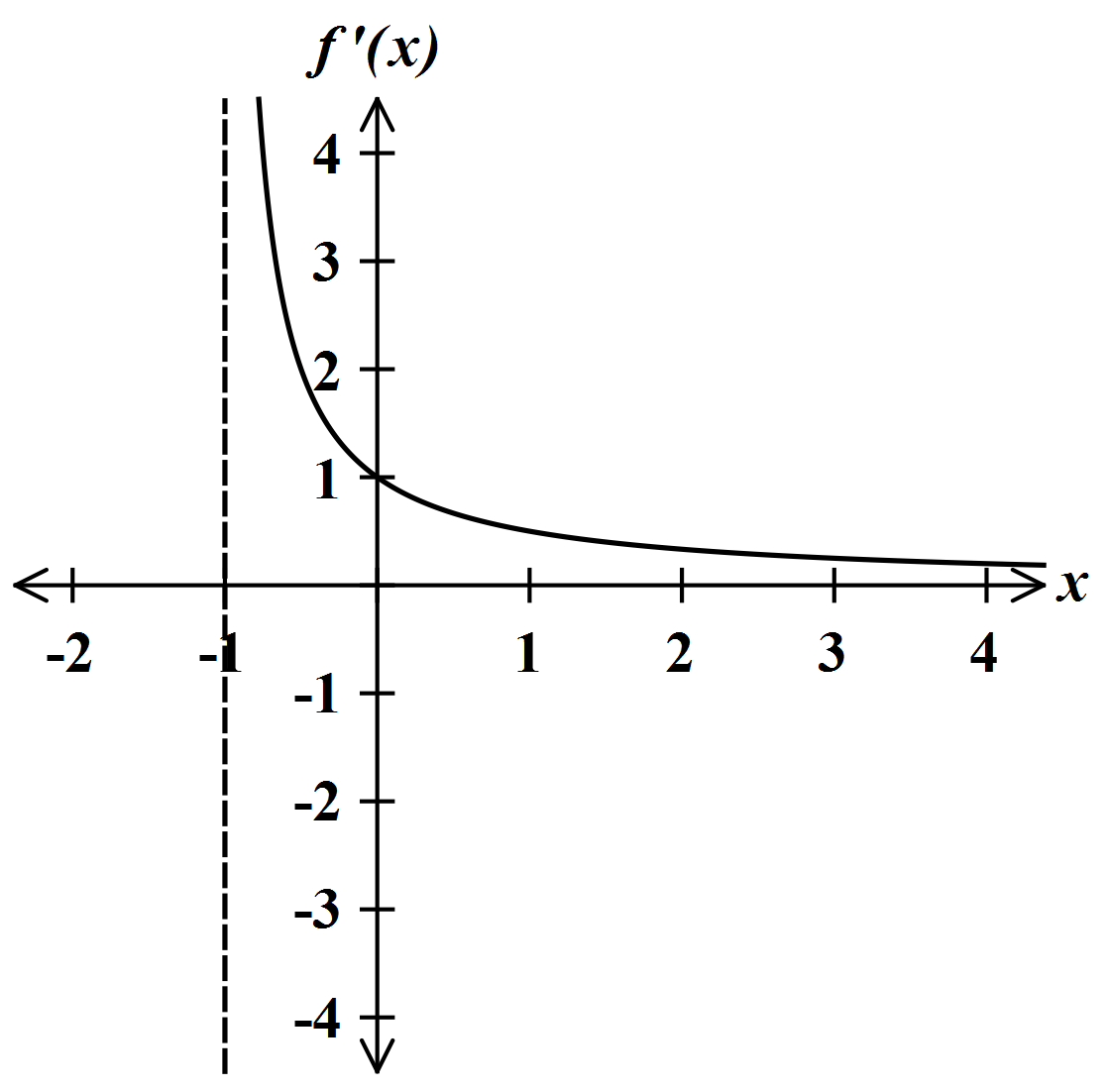

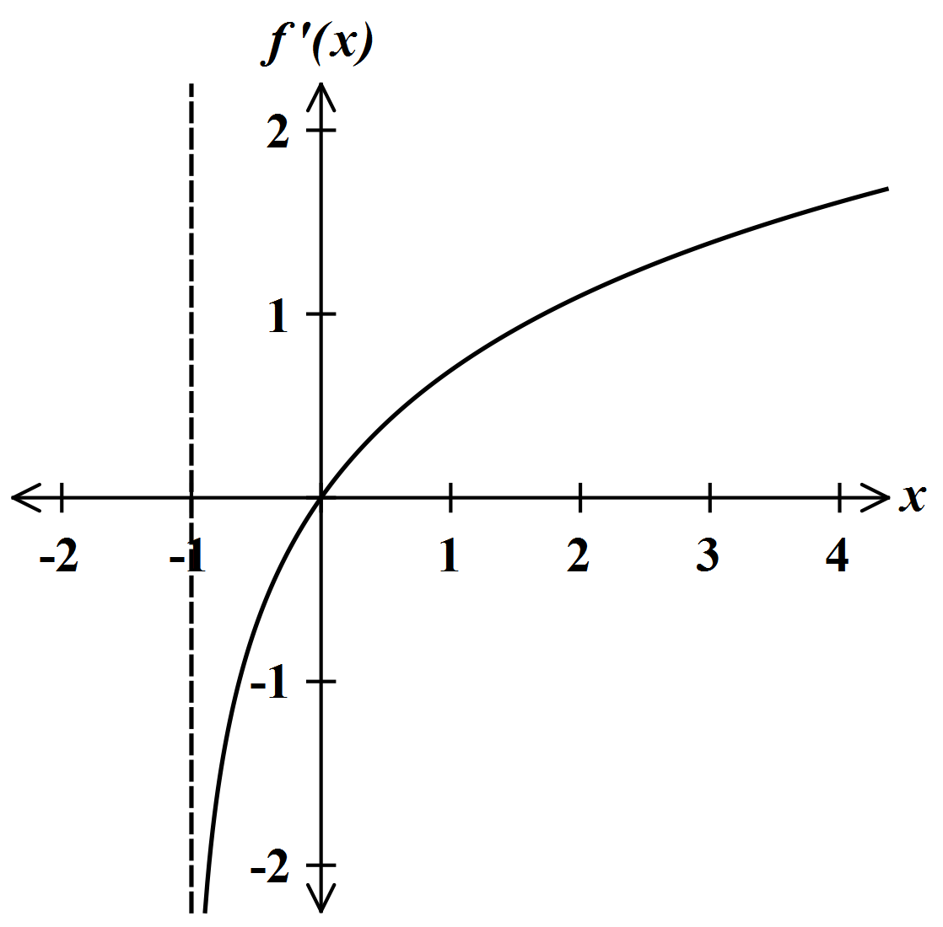

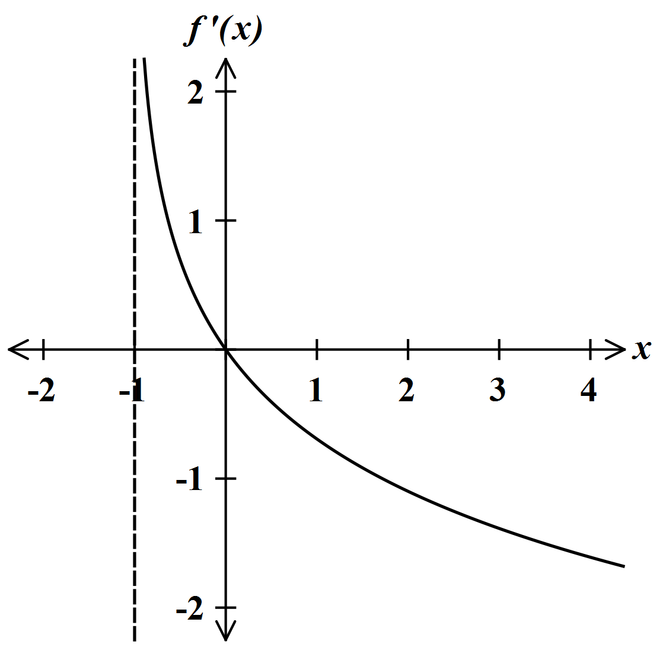

(A)

(B)

(C)

(D)

.

**SECTION II**

**QUESTION 11** Marks allocated as shown

*Start this question in a SEPARATE answer booklet* **Marks 15**

1. Find the equation of the tangent to the curve $y=3x^{2}$ at the point $x=1$. **2**Leave your solution in general form.
2. Prove the following trigonometric identity: $sinθcosθ{cosec}^{2}θ=cotθ$**2**
3. Find $\lim_{x→1}{\frac{x^{4}-x^{2}}{x^{2}-1}}$**2**
4. Find $\int{e^{3x+1}dx}$**2**
5. The cubic function $y={ax}^{3}+{bx}^{2}+cx+d$ has a point of inflexion at $x=p$. **2**  
   Show that $p=-\frac{b}{3a}$
6. Differentiate $y=x^{2}e^{2x}$ with respect to $x$. Fully factorise your solution. **2**
7. Evaluate $\int_{3}^{4}{\frac{\left(4x-5\right)}{\left({2x}^{2}-5x\right)}dx}$ leaving your answer in exact form. **3**

**QUESTION 12** Marks allocated as shown

*Start this question in a SEPARATE answer booklet* **Marks 15**

1. The quadratic equation $x^{2}-6x+2=0$ has roots $α$ and $β$. Find
2. $α+β$**1**
3. $αβ$**1**
4. $\frac{1}{α}+\frac{1}{β}$**1**
5. Solve $2^{2x+1}=64$**2**
6. The gradient of a curve is given by $\frac{dy}{dx}=6x-2$. The curve passes through the **2**  
   point $\left(-1, 4\right)$. What is the equation of the curve?
7. A batch of 1200 USB drives is examined. The probability of an individual USB being **2**  
   defective is 0.04.

How many USB drives from this batch would be expected ***not*** to be defective?

1. Greg and Peter are playing a game in which they take turns throwing two dice.   
   The game is won by the first person to throw a double of any kind (ie 6,6 or 5,5 or 4,4...)  
   Greg throws first.
2. Find the probability that Greg win the game with his first throw. **1**
3. What is the probability that Greg wins the game on the first or second throw? **2**
4. The tables provides the speed $V$ of a jogger at time $t$ in minutes over a 20 minute period. **3**  
   The speed $V$ is measured in metres per minute, in intervals of five minutes.

|  |  |  |  |  |  |
| --- | --- | --- | --- | --- | --- |
| $$t$$ | 0 | 5 | 10 | 15 | 20 |
| $$V$$ | 173 | 81 | 127 | 195 | 168 |

The distance covered by the jogger over the 20 minute period is given by $\int_{0}^{20}{V}dt$.  
  
Use Simpson’s Rule and the speed at each of the five time values to determine the approximate  
distance covered by the jogger in the 20 minute period. Give you answer correct to the nearest metre.

**QUESTION 13** Marks allocated as shown

*Start this question in a SEPARATE answer booklet* **Marks 15**

* 1. Differentiate the following functions with respect to .  
     1. **1**
     2. **2**
     3. **2**

* 1. Show that $f\left(x\right)=\frac{2x}{x-3}$ is decreasing for all values of $x≠3$. **3**
  2. After a severe injury, Arjun was taken to hospital and given medicine. For the first five  
     hours the amount $M ml$ of medicine present in Arjun’s bloodstream at any time is given by $M=t^{3}-6t^{2}+9t$ 
       
      for $0≤t≤5$ ( $t$ hours)

i. Find the time(s) when Arjun had no medicine in his bloodstream. **1**

1. For the function find all stationary points and determine their nature. **4**
2. Sketch the curve $M=t^{3}-6t^{2}+9t$ for $0≤t≤5$. **2**

**QUESTION 14** Marks allocated as shown

*Start this question in a SEPARATE answer booklet* **Marks 15**

|  |  |  |
| --- | --- | --- |
|  | |  |
|  |  |

1. A quadratic equation is given by , where .  
   * 1. Find the discriminate in terms of $a$. **1**
     2. Hence find the value of $a$ so that ${ax}^{2}-12x+10>0$, for all values of $x$. **2**
2. Solve $2\sin^{2}x=sinx$ for $0≤x≤{360}^{°}$**3**

*y*

*x*

A

O

$$y=x^{2}-3x$$

$$y=5x-x^{2}$$

Diagram not to scale

The diagram shows the parabolas $y=5x-x^{2}$ and $y=x^{2}-3x$. The parabolas intersect  
at the origin and the point A. The region between the two parabolas is shaded.

1. Show the area bounded by the parabolas $y=5x-x^{2}$ and $y=x^{2}-3x$ can be **3**  
   expressed as  
     
   Area, $A=\int_{0}^{4}{8x-{2x}^{2}dx}$
2. Hence find the area bounded by the parabolas $y=5x-x^{2}$ and $y=x^{2}-3x$. **2**
3. The shape of a metal stud is created by rotating the curve $y=e^{x}-e^{-x}$ about the *x*-axis **4**  
   between $x=0$ and $=\frac{1}{2}$.  
     
   Find the volume of this metal stud giving your answer in exact form.

**End of Assessment #2**

|  |  |  |  |
| --- | --- | --- | --- |
|  | |  | |
|  |  | |
|  |  | |